

May 17th, 2016

**Rep Alert – MET/BASE Upgrade Promotion**

Dear Sales Partner,

Please find below all the details on a promotion with respect to the phased end of life of MET/BASE.

**Customer promotion**

**Order your MET/SUPPORT Gold subscription for one year with 10% discount and receive a free of charge upgrade to the latest version of MET/BASE and receive the corresponding licenses for MET/TEAM Express free of charge**

**For full information on the introduction of MET/TEAM 2.1, MET/CAL 9 and End of Life of MET/BASE, please** [click here.](http://content.fluke.com/emails/europe/fcal/metbase_upgrade/now%20is%20the%20time%20to%20upgrade.docx)

**Time frame**:   
May 1st – October 1st, 2016

**How to promote:**

* Promotional webpage and banner on FCAL website:   
  [http://eu.flukecal.com/](http://eu.flukecal.com/free-probe-with-metrology-well)node/93775  
  <http://eu.flukecal.com/de/node/94623>

<http://eu.flukecal.com/fr/node/94624>  
<http://eu.flukecal.com/es/node/94625>

<http://ru.flukecal.com/node/94628>

* 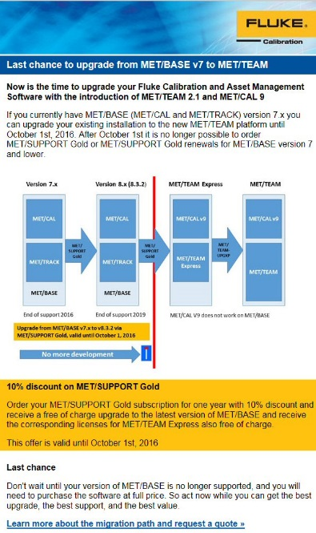Promotional banner on distributors’ websites.  
  If you need the banner in local language or in a different size, please contact gerda.meijer@flukecal.com
* Html mail to end customers  
  Please send to your own customer database

### How to order: Place your order for MET/SUPPORT Gold with the text METBASE_UPGRADE_PROMOTION

With kind regards,

EMEA Fluke Calibration Team